BUSINESS PLAN

COMPANY NAME
Date
Address
Website
Email address

CONFIDENTIAL

How to use this business plan template

[PLEASE DELETE all italicized orange sections – like this one – after you complete the section. This information is provided to help you understand the section and/or provide an overview or instructions. Once you finish, you no longer need that guidance.

Use this business plan template as a roadmap to understanding your business, navigating your market and achieving your business objectives. Filling out this plan will help you focus your actions. You can revisit this document periodically to compare your plans with where you're at and course-correct as needed. You can also use this plan externally, sharing it with your investors, lenders or landlords.

Template designed by Tiffany C. Wright for Samsung Business Insights, 2022.]

Background
[This section provides a summary of the key information about your company. You can copy/paste the template text boxes to add additional goals.]

The purpose of this business plan is to … [brief description of plan's purpose]. [Company's legal name and DBA, if applicable] is based in [city, state] and was incorporated/organized in [state] in [month/year]. This plan specifies how the company will achieve the following goals:

Description

Timeframe
Goal #1
Description

Timeframe
Goal #2

The company is [percent] owned by [name of person]. [Name] provides [products/services] to [market] within [region].

The company's vision is … [description of vision]. The company's mission is … [description of mission].

[Example: The purpose of this business plan is to support the recruitment of key personnel. This plan specifies how the company will develop and grow to $2 million in revenue and 15 percent profitability in the next three years. …]

Products
and services

[This section summarizes the types of products and services your company offers and the industry, market or types of customers you serve.]

[Company] specializes in [general description of products and services]. It provides [more in-depth description of core products and services] to [general description of market or customer types]. The company also provides [in-depth description of additional products and services] to [market or customer types].

Industry or market overview

[This section conveys the market opportunity. To complete this section, you'll need to conduct research on the market.
- Complete this section by carrying out the actions noted.
- Reference credible industry research reports such as IBISWorld or Deloitte, or sources such as Hoover's or the Bureau of Labor Statistics (BLS). Another possible source is the 10K of a publicly traded company that sells similar products/services or serves the same market. A 10K is essentially a formatted, detailed annual report, available online from the SEC's Edgar database.
- Summarize the research findings on your industry's size, growth rates and significant trends. Focus on justifying a sufficiently sizeable market for your business to join. Cite your sources.
- Provide a brief overview of the local or regional market, as applicable. Cite local business journals or other relevant research sources.
Example: According to Source A, the promotional products industry was down in 2020. One-third of distributors rate the industry as robust, while less than 10% rate it as ailing. The majority of distributors had an increase in sales and profitability due to a market strategy that ...]

Competitive position

[In this section, communicate your understanding of your competitors, your ideal customer and your competitive advantages.]

[Legal name of competitor], based in [city, state], has been serving the [industry] market in [location] for [amount of time]. [Competitor] was founded in [year] and now generates [dollar amount] in revenue and has [number] employees. The company provides [products/services, general description] to [type of customer]. The company is known for [reasons customers buy from them].

[Legal name of second competitor] ... [provide the same information as above].

[Legal name of third competitor] ... [provide the same information as above].

Ideal customer
[Company's] ideal customer operates in the [specific industry], reads [publications, blogs, other media], has an online presence on [digital platforms] and hangs out in/at [frequented locations, events]. They are ... [description of relevant demographics, e.g., age range, education level].

Competitive advantage
[Company] is known for its ... [describe what sets you apart from your competitors and allows you to charge more].

[Example: Our company's competitive advantage is its focus on delivering in-depth, healthcare industry-specific research and guidance from healthcare personnel ...]

Go-to-market strategy

[In this section, summarize your goals and strategy for achieving them. You can copy/paste the template text boxes to add additional goals.]

[Company] will achieve [dollar amount] in revenue and [dollar amount] in profits.
By the end of year 3….
[Company] will achieve [dollar amount] in sales revenue. It will also ...
By the end of year 1….

Product and service delivery
[Company] delivers its products and services through [delivery method]. [Company] uses [sales methods, e.g., direct sales, partnerships, distributors] to grow its marketing footprint.

The customer prefers to be served by [delivery method, e.g., platform, website, in-person]. To accomplish this, [company] uses [specific technology used to serve customer].

Marketing and sales
[This subsection explains how you will market and drive sales.

- Describe where your customers are and where they like to hang out. Describe whether they interact with groups, attend workshops or read blogs. Describe how you will use this information to make your sales and marketing efforts more compelling.]

Management

[Use this section to convey the strength of your company's management.
- Since your business is new, major customers, suppliers, investors and others will place significant emphasis on your management team.
- Provide a three-to-five-sentence summary of each of your founders and executive team members. If there is only you but you intend to hire someone soon, summarize this upcoming role and use a placeholder such as "TBD, General Manager."
- Add a brief listing of people who assist you in areas outside your range of expertise, such as marketing, legal or accounting.
- You can copy/paste the template text boxes to add additional team members.]
[Founder] is the CEO / president / general manager of [company]. [They] are ...
Title
Title
[Co-founder] is the vice president of sales / CTO of [company]. [They] are ...

Advisory board
[Advisory board member 1] is [title] at [company], [description of company]. [They] have ___ years of experience in ...
Advisory Board Member Name

[Advisory board member 1] is [title] at [company], [description of company]. [They] have ___ years of experience in ...
Advisory Board Member Name

Financing

[This section provides an overview of your funding status and where you obtained the funding.
- If you will use this plan to seek funding, add a table outlining funding sources and uses, and attach financial projections.]
[Company] is [percent] funded by its founders. The founders injected [dollar amount] in capital to cover startup expenses and [other expenses, e.g., certain operating costs, hire personnel]. [Company] intends to fund business growth by [specific methods].

Revenue model

[Briefly describe how you will monetize sales.]

[Company] will sell its products as [type of items, e.g., individual/packaged, more information as needed]. [Company] will sell its services [method of providing services, e.g., on an hourly basis, as a value-driven package.] [Add more information as needed.]

[Example: Our company will deploy a subscription revenue model. However, our company will occasionally sell one-off research reports to small entities.]

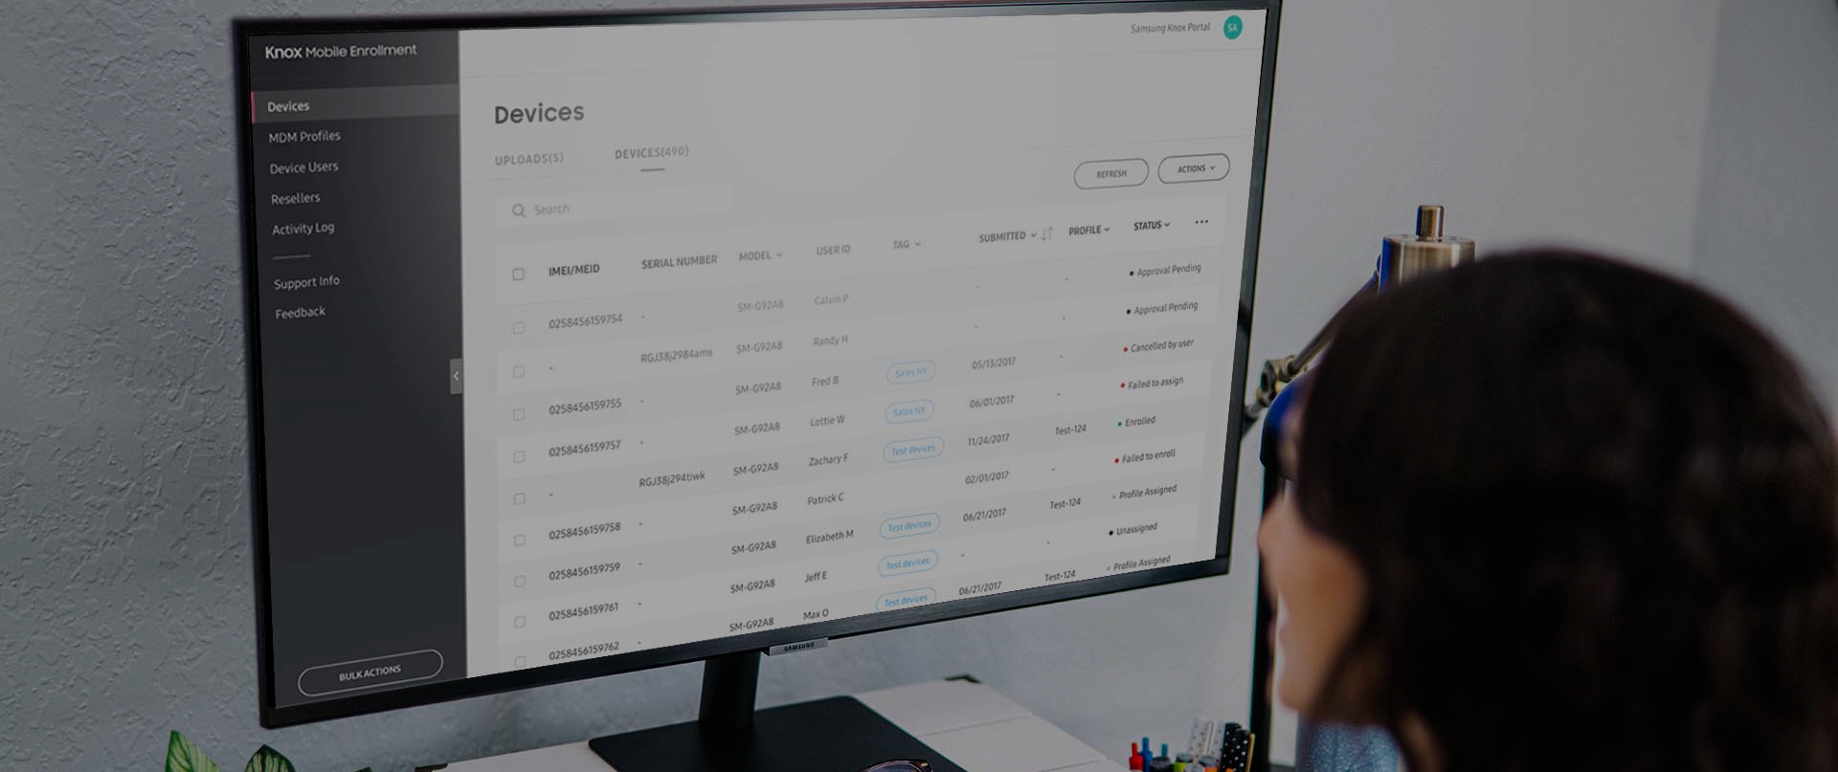
Technology
and operations

[Describe the basic operational structure of your business, including help needed and why.]

[Company] will initially operate from [location]. [Company] will [outsource / use independent contractors] but intends to hire employees when [specific circumstances].

Technology
[Company] uses [specific software] to [purpose of software]. It also uses [type of technology, e.g., mobile phones/apps] to [purpose of technology].

